Response to Reviewers

Reviewer: 1  
Comments to the Author  
# Summary  
Singh, et al. present a new method, DIABLO, for supervised biomarker discovery of multiple ‘omics datasets. More specifically, DIABLO is designed to overcome the computational challenge of identifying molecular features in different datasets predictive of a phenotypic response (e.g. cancer subtype). This is an important and difficult challenge given the scale of ‘omics data and that it is increasingly common for researchers to take multiple types of molecular measurements (e.g. mRNA, miRNA, protein expression, …) per sample. Singh, et al. use a matrix factorization approach, specifically a generalized version of canonical correlation analysis to incorporate supervision in the form of phenotypic labels. They demonstrate DIABLO on simulated and real data, including a breast cancer and asthma dataset, and compare supervised/unsupervised and integrative/non-integrative approaches. The results on both simulated and real data are somewhat mixed.  
  
Overall, the DIABLO method is novel and interesting, as are the applications and some of the analysis. However, despite these contributions, I recommend that the authors revise their manuscript for two main reasons. First, in multiple places the manuscript reads like a draft and requires major edits. Second, the analysis of the results of DIABLO on simulated and real data is incomplete. I elaborate on these and other points below.  
  
# Major comments  
(1) In many places the manuscript reads like a draft and/or is missing key details, and also includes many typos. These include:  
* Limited motivation for the new supervised approach. In particular, there is no substantive review of related work. As such, the authors’ claim that existing “supervised strategies are unable to capture the shared information across multiple biological domains when identifying the key molecular drivers associated with a phenotype” (page 3) is unsupported.

We agree with the reviewer that compressive review of current knowledge and gaps would benefit the motivation of our approach. Therefore, we have included a summary of various data integration methods and their appropriate uses: The revised introduction reads as follows:

Technological improvements have allowed for the collection of data from different molecular compartments (*e.g.* gene expression, methylation status, protein abundance) resulting in multiple omics (multi-omics) data from the same set of biospecimens (*eg.*, transcriptomics, proteomics, metabolomics). Systems biology approaches which incorporated data from multiple biological compartments, have shown improved biological insights compared to traditional single omics analyses (Zhu *et al.*, 2012; Kim *et al.*, 2013; Wang *et al.*, 2014). This may be because single omics analyses cannot account for the interactions between omic layers and, consequently, are unable to reconstruct accurate molecular networks. These molecular networks are dynamic, changing under perturbed conditions such as disease, response to therapy, and environmental exposures. Therefore, adopting a holistic approach by integrating multi-omics data may bridge this information gap, and uncover networks that are representative of the underlying molecular mechanisms (Ritchie *et al.*, 2015; Yugi *et al.*, 2016).

Many strategies (component-based, message-passing, Bayesian, network-analysis, classification schemes) have been proposed for multi-omics data integration to answer various questions, incorporating experimental data as well as curated data from biological databases (Supplementary Figure S1) (Zeng and Lumley, 2018; Ritchie *et al.*, 2015; Bersanelli *et al.*, 2016; Meng *et al.*, 2016; Huang *et al.*, 2017; Rohart *et al.*, 2017). These includes data-driven methods for identifying novel phenotypic clusters such as Similarity Network Fusion (Wang *et al.*, 2014) (SNF), Bayesian Consensus Clustering (BCC) (Kirk *et al.*, 2012), iClusterPlus+ (Curtis *et al.*, 2012), and methods for extracting common sources of variation such as joint Non-negative Matrix Factorization (NMF) (Zhang *et al.*, 2012), Joint and Individuation Variation Explained (JIVE) (Lock *et al.*, 2013), sparse MultiBlock Partial Least Squares (sMBPLS) (Li *et al.*, 2012), Regularized and Spare Generalized Canonical Correlation Analysis (RGCCA, SGCCA) (Tenenhaus and Tenenhaus, 2011; Tenenhaus *et al.*, 2014) and Multi-Omics Factor Analysis (MOFA) (Argelaguet *et al.*, 2018). Other methods such as Passing Attributes between Networks for Data Assimilation (PANDA) (Glass *et al.*, 2013), Sparse Network regularized Multiple Non-negative Matrix Factorization (SNMNMF) (Zhang *et al.*, 2011) and Reconstructing Integrative Molecular Bayesian NETworks (RIMBANET) (Zhu *et al.*, 2012) can be used to incorporate curated data (*e.g.* PPI data, miRNA relationships, transcription factor binding motifs) with experimental data in order to reconstruct biological networks. All of these methods are examples of unsupervised multi-omics data integration, that is, without the need of sample labels that categorize samples based on a certain phenotype or trait. However, often times researchers are interested in multi-omics biomarkers that are predictive of disease, that is, supervised data integration in which molecular patterns that span across biological domains are different with respect to a given phenotype. Method development in this area of research has been limited and requires further exploration.

Preliminary approaches to supervised data integration for the classification of multi-group phenotypes (e.g. PAM50 breast cancer phenotypes) included multi-step approaches such as concatenation-based in which the multi-omics data was concatenated and then a classification model was applied or ensemble-based in which a separate classification model was applied separately to each omics data and the resulting predictions were combined using various schemes (*e.g.* average or Majority vote) (Günther *et al.*, 2012). These approaches can be biased towards certain omics data types, however, and do not account for interactions between omic layers (Aben *et al.*, 2016; Ma *et al.*, 2016). Recently classification approaches such as Network smoothed t-statistics Support Vector Machines (stSVM) (Cun and Fröhlich, 2013), Generalized Elastic Net (GELnet) (Sokolov *et al.*, 2016), and adaptive Group-Regularized ridge regression (GRridge) (van de Wiel *et al.*, 2016) have incorporated curated biological data such as PPI data, genetic pathway data, and type of methylation probes. These methods are still limited to a single omics data such that either the concatenation-based and ensemble-based schemes must be applied to incorporate additional data-types. The Analysis Tool for Heritable and Environmental Network Associations (ATHENA) is a Grammatical Evolution Neural Network (GENN) that integrates multi-omics data for the prediction of clinical outcomes (Kim *et al.*, 2013), however the initial filtering and GENN modelling is performed separately on each omics dataset and only the variables from the best models are combined in a GENN. We sought to develop a supervised data integration method that simultaneously performed variable selection, data integration and classification of multiple phenotypic groups.

We introduce DIABLO, a method that incorporates information across high dimensional multi-omics data while discriminating phenotypic groups. DIABLO (**D**ata **I**ntegration **A**nalysis for **B**iomarker discovery using **L**atent c**O**mponents) maximizes the common or correlated information between multiple omics (multi-omics) datasets while identifying the key omics variables (mRNA, miRNA, CpGs, proteins, metabolites, *etc.*) and characterizing the disease sub-groups or phenotypes of interest. DIABLO is, therefore, an integrative classification method that builds predictive multi-omics models that can be applied to multi-omics data from new samples to determine their phenotype. Users can specify the number of variables to select from each dataset and visualize the omics data and the multi-omics panel into a reduced data space. The method is highly flexible in the type of experimental design it can handle, ranging from classical single time point to cross-over and repeated measures studies. Modular-based analysis can also be incorporated using pathway-based module matrices (Langfelder and Horvath, 2008) instead of the original omics matrices, as illustrated in one of our case studies.

We demonstrate the capabilities and versatility of DIABLO both in simulated and real-world data, integrating multi-omics datasets to identify relevant biomarkers of various diseases. DIABLO is available through the mixOmics data integration toolkit, [www.mixomics.org](http://www.mixomics.org) (Rohart *et al.*, 2017) which contains a wide range of multivariate methods for the exploration and integration of high dimensional biological datasets.

* Confusing presentation of the DIABLO algorithm. The authors should write out the DIABLO algorithm in full.  
* Confusing presentation of the sGCCA algorithm. The notation for a_h^k is inconsistent, and more importantly, all a_h^k are completely missing from the objective of the optimization problem. Further, the authors do not review how sGCCA solves the optimization problem.  
* Never defining sPLSDA  
* Never defining N_new  
* “validatio” —> “validation” (page 2)

TO ADD!

(2) The results on simulated and real data are also concerning, particularly in the comparatively worse performance of DIABLO (full) at classification (full refers to the design matrix which controls which omics datasets are “connected”).  
* It is concerning that DIABLO (full) has the worst phenotypic classification performance on simulated data. The authors claim that there is a tradeoff between discrimination and correlation, and that DIABLO is better at selecting interpretable variables. This makes sense, but is unexplored and incomplete. The authors should extend their simulation analysis to show settings in which DIABLO (full) is at least as good as existing methods, and whether the design matrix can be used to achieve stronger classification performance even in the current simulated data setup.

* On simulated data, the authors only perform limited benchmarking against existing approaches, only comparing to sPLSDA, and do not provide an explanation for this missing analysis. There is more extensive benchmarking on real data.

In agreement with the reviewer, we have extended the simulation analyses to address a number of other questions:

1. Relationship between the covariance (between datasets) and the error rate and number of variables selected
2. Improving the classification error rate of the full design by adding more uncorrelated (independent) information through additional components

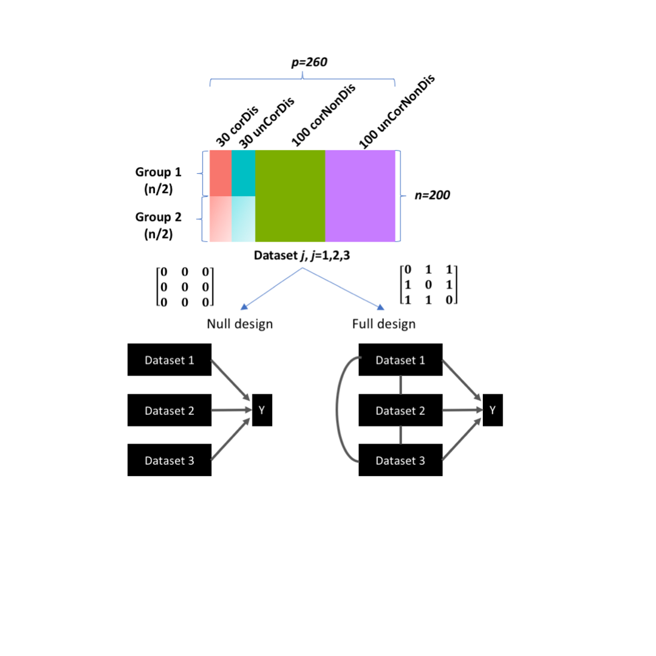

Three datasets were simulated each with 200 observations (n) and 260 variables (p). The 200 observations were split equally over two groups (G1 and G2), whereas the 260 variables were generated by varying the covariance ($σ_{XY}^{2}=[0,5,10,15]$) between datasets and fold-change (δ=[0,1,2]) between G1 and G2: 30 correlated-discriminatory (corDis) variables, 30 uncorrelated-discriminatory (unCorDis) variables, 100 correlated-nondiscriminatory (corNonDis) variables, and 100 uncorrelated-nondiscriminatory (unCorNonDis) variables were simulated (Figure 1A). The resulting dataset was of the form:

+ , where j = 1, 2, 3

The matrix containing correlated and discriminatory variables, was generated using the following model:

**Figure. Simulated multi-omics data.** Each simulated dataset consisting of four types of variables: 30 correlated-discriminatory (corDis) variables, 30 uncorrelated-discriminatory (unCorDis) variables, 100 correlated-nondiscriminatory (corNonDis) variables and 100 uncorrelated-nondiscriminatory (unCorNonDis) variables

, where

where the loadings, **w**1, **w**2, and **w**3 were 30-vectors, and the elements were drawn from a uniform distribution in the interval of [-0.3, 0.2] U [0.2, 0.3]. For G1, the outer components , , were 3-vectors drawn from a multivariate normal distribution with a mean value of 0 and a mean value of δ=[0,1,2] for G2. The covariance between pairs of components was set to cov(,) = $σ_{ij}^{2}$ (for) where $σ_{ij}^{2}$ =[0,5,10,15] and cov(,) =0 (for *i*=*j*).

The matrix containing uncorrelated and discriminatory variables, was generated using the following model:

, where

where the loadings, **w**1, **w**2, and **w**3 were 30-vectors, and the elements were drawn from a uniform distribution in the interval of [-0.3, 0.2] U [0.2, 0.3]. For G1, the outer components , , were 3-vectors drawn from a multivariate normal distribution with a mean value of 0 and a mean value of δ=[0,1,2] for G2. The covariance between pairs of components was set to cov(,) = 0 for all *i* and *j*.

The nondiscriminatory variables (corNonDis and unCorNonDis) were generated by drawing 100-vectors each with 200 elements, from a multivariate normal distribution with a mean of 0. For correlated variables, the covariance between pairs of components was set to cov(,) = $σ_{ij}^{2}$ (for) where =[0,5,10,15] and cov(,) =0 (for *i*=*j*). For uncorrelated variables the covariance between pairs of components was set to cov(,) = 0 for all *i* and *j*. ***E****j* is a 200 x 260 residual matrix where each element is drawn from a normal distribution with zero mean and variance equal to 0.5.

For each simulated set of datasets (for a given covariance and fold-change level), DIABLO models were constructed either with the null or full design and their performance was evaluated using 10-fold cross-validation. This procedure was repeated 20 times and the error rates were averaged.

1. Relationship between the covariance (between datasets) and the error rate and number of variables selected

We agree with the reviewer that in the previous manuscript draft we discussed the trade-off between discrimination and correlation but did not explicitly explore it further. Therefore, in the reanalysis we have incorporated the covariance between datasets as a tunable parameter.



The figure above depicts contour plots of the error rate for different degrees of covariance and fold-change (signal) either using the full or null design in the diablo models (selecting 60 variables on 1 comp) (see Figure 1A for the design matrices). As can be observed from the figure on the left, increasing the covariance between datasets significantly increases the error rate (blue to red) for a given fold-change. The same is not observed for the Null design (right figure) where the error rate is roughly constant for given effect size, irrespective of the covariance between datasets.

1. Improving the classification error rate of the full design by adding uncorrelated (independent) information.

As discussed previously the reason for higher error rate for full design, is the lack of independent information that is captured as compared to the null design. For example, a DIABLO_Null model generated from 3 datasets retaining 1 component per datasets, results in 3 components that are less correlated compared to components generated from a DIABLO_Full model. This is due to the constraint in the full design that a common source of variance exists between datasets such that all extract components should be correlated. This is useful when exploring shared biological pathways between biological datasets but in the context of classification less useful since less independent information is captured.

However, the error rate of the DIABLO_Full model can still be improved using a ‘deflation’ of the residual data matrices once the first components has been extracted from all datasets. Therefore, the second components will be orthogonal to the first components but still be correlated with the other second components. Since the prediction happens separately for each omic dataset, the correlation between components does not negative affect the performance of the DIABLO model.



The figure above depicts contour plots of the error rate for different degrees of covariance and fold-change (signal) either using the full or null design in the diablo models (selecting 30 variables on each of the 2 components for total o­f 60 variables). Since the two components are independent, the variables selected on the second component are uncorrelated with those from the first component but still predictive of the outcome, resulting in a lower error rate.

1. Selecting all discriminatory variables when comparing error rates between DIABLO and existing classification methods.

As the reviewer recommended, we have extended the simulation analysis to show settings in which DIABLO (full) is at least as good as existing methods, and whether the design matrix can be used to achieve stronger classification performance even in the current simulation setup.

* Some of the results on real data are not well-explained and/or do not have sufficient context.  
* For example, there are quite substantial error rates for predicting PAM50 breast cancer subtypes (ranging from ~5-50%). How are these results to be interpreted? The PAM50 subtypes have known clinical implications, so if the authors find subtypes that are refined or different from PAM50, they should provide some sort of validation (e.g. with clinical data such as survival). Otherwise, what is the point of using supervision?

The purpose of this analysis was focused more on application of DIABLO to multiclass phenotypes and to the biological interpretation of the variables selected and less on the classification error rate. We describe that some phenotypes are easier to separate (Basal, Her2) as compared to other subtypes (LumA, and LumB), as we depict using various illustration such as component plots, and heatmaps. We apologize for any confusion as the purpose of this analysis was to identify multi-omics panels that were predictive of PAM50 subtypes and not to identify new subtypes. Therefore down validation such as through surivival analysis is not in the scope of this paper.

* The description of the “multilevel DIABLO” approach is confusing, and does not seem to be discussed in the Methods (though the authors say it is in the Results on page 23).  
Due to the word limit restrictions, this section was moved to the supplementary materials and was not corrected in the main text. We apologize for this over sight. Additional details for this approach can be in Supplementary Section 7 and is stated as follow:

For multivariate analyses, A multilevel approach separates the within subject variation matrix (*Xw*) and the between subject variation (*Xb*) for a given dataset (*X*) (Westerhuis *et al.*, 2010; Liquet *et al.*, 2012), ie. *X = Xw + Xb*. In the case of a two-repeated measured problem (e.g. pre vs post challenge), the within subject variation matrix is similar to calculating the net difference for each individual between the data obtained for pre and post challenge. For each omics dataset, the within-subject variation matrix was extracted prior to applying DIABLO. In the asthma study, the multilevel approach (called variance decomposition step) was applied to the cell-type, gene and metabolite module datasets.

# Minor comments  
* The authors have integrated DIABLO into their mixOmics R package, and it seems well-documented.  
* What is the runtime and memory footprint of DIABLO?  
We have previously comment on this memory footprint in our software paper on all mixOmics methods (Rohart *et al.*, 2017). The following Supplementary Table describes the run time for datasets of different sizes. The tune function is used to identify the number of variables to select from each dataset using cross-validation and grid of values for the number of components and number of features to select per component. The runtime for the tune function is dependent on the grid size and the number of components that are retained. The perf function is used to perform cross-validation for a given number of features to select per component.

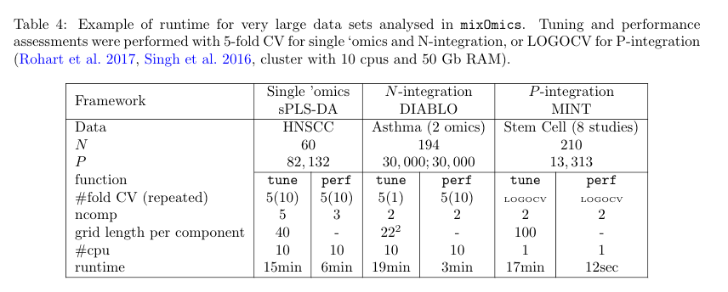

Reviewer: 2  
Comments to the Author  
In their manuscript the authors present a method (DIABLO) to integrate data from multiple omics in a semi-supervised manner providing a balance between unsupervised methods that do not take into account known labels and supervised methods that do not take into account correspondence structures between omics. The method is based upon sGCCA (Tenenhaus et al al 2014) by including the labels as an additional block and implemented as part of the mixOmics package.   
  
Overall, the method and the results are presented in a clear manner and the method seems to provide a good balance between supervised and unsupervised approaches. The authors demonstrate the ability of the method to find correlated discriminative features in simulations and convincingly show that the method is able to infer discriminative and biological meaningful components in several applications. More care could be taken when discussing the relationship of the proposed methods to existing approaches and in evaluating its predictive performance.  
  
Major comments:  
1. In the introduction the authors comment on supervised and unsupervised methods, however they do not relate their method to existing methods that aim at partly supervised integration of multiple data types such as for example sparse Multi-Block Partial Least Squares or sparse supervised CCA. This relationship and the contributions should be discussed more carefully.

We agree with the reviewer that compressive review of current knowledge and gaps would benefit the motivation of our approach. Therefore, we have included a summary of various data integration methods and their appropriate uses: The revised introduction reads as follows:

Technological improvements have allowed for the collection of data from different molecular compartments (*e.g.* gene expression, methylation status, protein abundance) resulting in multiple omics (multi-omics) data from the same set of biospecimens (*eg.*, transcriptomics, proteomics, metabolomics). Systems biology approaches which incorporated data from multiple biological compartments, have shown improved biological insights compared to traditional single omics analyses (Zhu *et al.*, 2012; Kim *et al.*, 2013; Wang *et al.*, 2014). This may be because single omics analyses cannot account for the interactions between omic layers and, consequently, are unable to reconstruct accurate molecular networks. These molecular networks are dynamic, changing under perturbed conditions such as disease, response to therapy, and environmental exposures. Therefore, adopting a holistic approach by integrating multi-omics data may bridge this information gap, and uncover networks that are representative of the underlying molecular mechanisms (Ritchie *et al.*, 2015; Yugi *et al.*, 2016).

Many strategies (component-based, message-passing, Bayesian, network-analysis, classification schemes) have been proposed for multi-omics data integration to answer various questions, incorporating experimental data as well as curated data from biological databases (Supplementary Figure S1) (Zeng and Lumley, 2018; Ritchie *et al.*, 2015; Bersanelli *et al.*, 2016; Meng *et al.*, 2016; Huang *et al.*, 2017; Rohart *et al.*, 2017). These includes data-driven methods for identifying novel phenotypic clusters such as Similarity Network Fusion (Wang *et al.*, 2014) (SNF), Bayesian Consensus Clustering (BCC) (Kirk *et al.*, 2012), iClusterPlus+ (Curtis *et al.*, 2012), and methods for extracting common sources of variation such as joint Non-negative Matrix Factorization (NMF) (Zhang *et al.*, 2012), Joint and Individuation Variation Explained (JIVE) (Lock *et al.*, 2013), sparse MultiBlock Partial Least Squares (sMBPLS) (Li *et al.*, 2012), Regularized and Spare Generalized Canonical Correlation Analysis (RGCCA, SGCCA) (Tenenhaus and Tenenhaus, 2011; Tenenhaus *et al.*, 2014) and Multi-Omics Factor Analysis (MOFA) (Argelaguet *et al.*, 2018). Other methods such as Passing Attributes between Networks for Data Assimilation (PANDA) (Glass *et al.*, 2013), Sparse Network regularized Multiple Non-negative Matrix Factorization (SNMNMF) (Zhang *et al.*, 2011) and Reconstructing Integrative Molecular Bayesian NETworks (RIMBANET) (Zhu *et al.*, 2012) can be used to incorporate curated data (*e.g.* PPI data, miRNA relationships, transcription factor binding motifs) with experimental data in order to reconstruct biological networks. All of these methods are examples of unsupervised multi-omics data integration, that is, without the need of sample labels that categorize samples based on a certain phenotype or trait. However, often times researchers are interested in multi-omics biomarkers that are predictive of disease, that is, supervised data integration in which molecular patterns that span across biological domains are different with respect to a given phenotype. Method development in this area of research has been limited and requires further exploration.

Preliminary approaches to supervised data integration for the classification of multi-group phenotypes (e.g. PAM50 breast cancer phenotypes) included multi-step approaches such as concatenation-based in which the multi-omics data was concatenated and then a classification model was applied or ensemble-based in which a separate classification model was applied separately to each omics data and the resulting predictions were combined using various schemes (*e.g.* average or Majority vote) (Günther *et al.*, 2012). These approaches can be biased towards certain omics data types, however, and do not account for interactions between omic layers (Aben *et al.*, 2016; Ma *et al.*, 2016). Recently classification approaches such as Network smoothed t-statistics Support Vector Machines (stSVM) (Cun and Fröhlich, 2013), Generalized Elastic Net (GELnet) (Sokolov *et al.*, 2016), and adaptive Group-Regularized ridge regression (GRridge) (van de Wiel *et al.*, 2016) have incorporated curated biological data such as PPI data, genetic pathway data, and type of methylation probes. These methods are still limited to a single omics data such that either the concatenation-based and ensemble-based schemes must be applied to incorporate additional data-types. The Analysis Tool for Heritable and Environmental Network Associations (ATHENA) is a Grammatical Evolution Neural Network (GENN) that integrates multi-omics data for the prediction of clinical outcomes (Kim *et al.*, 2013), however the initial filtering and GENN modelling is performed separately on each omics dataset and only the variables from the best models are combined in a GENN. We sought to develop a supervised data integration method that simultaneously performed variable selection, data integration of multiple datasets and classification of multiple phenotypic groups.

We introduce DIABLO, a method that incorporates information across high dimensional multi-omics data while discriminating phenotypic groups. DIABLO (**D**ata **I**ntegration **A**nalysis for **B**iomarker discovery using **L**atent c**O**mponents) maximizes the common or correlated information between multiple omics (multi-omics) datasets while identifying the key omics variables (mRNA, miRNA, CpGs, proteins, metabolites, *etc.*) and characterizing the disease sub-groups or phenotypes of interest. DIABLO is, therefore, an integrative classification method that builds predictive multi-omics models that can be applied to multi-omics data from new samples to determine their phenotype. Users can specify the number of variables to select from each dataset and visualize the omics data and the multi-omics panel into a reduced data space. The method is highly flexible in the type of experimental design it can handle, ranging from classical single time point to cross-over and repeated measures studies. Modular-based analysis can also be incorporated using pathway-based module matrices (Langfelder and Horvath, 2008) instead of the original omics matrices, as illustrated in one of our case studies.

We demonstrate the capabilities and versatility of DIABLO both in simulated and real-world data, integrating multi-omics datasets to identify relevant biomarkers of various diseases. DIABLO is available through the mixOmics data integration toolkit, [www.mixomics.org](http://www.mixomics.org) (Rohart *et al.*, 2017) which contains a wide range of multivariate methods for the exploration and integration of high dimensional biological datasets.

2. The authors convincingly demonstrate that the method is very good at finding biological meaningful components that well discriminate phenotypic groups. In terms of predictive performance there seems to be a risk, when concentrating on correlations between data sets, that DIABLO (with full or partly full design matrix) could overlook single strongly discriminative features in a data set when these have little correlation to other omic data sets. For example, in the simulation study DIABLO_Full mainly discovers correlated discriminative features. Would the method be able to discover all 180 discriminative features if 60 instead of 30 variables were selected from each data set?

In the previous analysis we had simulated 60 predictive variables per dataset (30 correlated and 30 uncorrelated), however as the reviewers suggests we can also allow for all methods to select 60 variables per dataset (180 in total) in order to determine whether all 180 discriminative features are selected. Three high dimensional datasets were simulated consisting of correlated variables across datasets (covariance set to 1) or uncorrelated variables (covariance set to 0). Half of these variables were predictive which was varied by modifying the mean of the centroids of the two groups. The null and full design were used to generate separate DIABLO models (Figure 1A). DIABLO models (either with the null or full design) were compared with existing integrative classification schemes with respect to the error rate and types of variables selected (**Figure 1B-C**). The error rate for each method was determined using 10-fold cross-validation averaged over 20 simulations. The covariance between datasets was held constant at 1, whereas the fold-change was varied from 0-2, and noise was varied from 0.2-1. As expected, the error rate was roughly 50% when the fold-change was zero, regardless of the noise level for all methods. When the fold-change was set to 1, the DIABLO model the full design (DIABLO_Full) had a higher error rate than all other methods, for noise levels less than 1 (Noise=0.2 and Noise=0.5). However, when the noise level was increased to match the level of the fold-change (Noise=fold-change=1) all methods performed similarly. When the fold-change was increased to 2 (higher than both the covariance and noise levels) the DIABLO_Full model performed similarly with all other methods.

Before:



After:



**Figure 1. Trade-off between correlation and discrimination in DIABLO models.** A) Simulated datasets were generated to consist of four types of variables: correlated & discriminatory (corDis); uncorrelated & discriminatory (unCorDis); correlated & nondiscriminatory (corNonDis) and uncorrelated & nondiscriminatory (unCorNonDis). The covariance between dataset was set to 1. The null or full design matrix was used to generate two different DIABLO models (DIABLO_Null and DIABLO_Full). B) left: Classification error rates (10-fold cross-validation averaged over 20 simulations). Dashed line indicates a random performance (error rate = 50%). All methods perform similarly when the fold-change (FC) was zero (first row). All methods performed similarly when the FC=2, that is, the fold-change was greater than the noise and covariance levels. When FC=1, DIABLO_Full had a higher error rate compared to the other methods for noise levels less than 1. right: At lower fold-change levels, DIABLO_Full selected correlated variables (red and green), however, when the fold-change was greater than the noise and covariance levels (FC=2), all methods selected all predictive variables (red, blue).

In addition, it would also be good to see a method comparison in terms of classification performance on real data (e.g. on the benchmark data sets by Wang et al 2014) using independent test sets.

The purpose of the benchmarking analyses was to compare the types of variables selected across different datasets and integrative methods. However, since the methods differed with respect to variable selection, and level of supervision and cohorts lacked independent test datasets, a comparison with respect classification performance was neglected. Instead in the revised analyses we have performed internal validation to assess for consistency within the phenotypic groups in the benchmarking experiments. As for the classification performance comparison, the only multi-omics datasets we could find with independent test sets was the breast cancer data with 370 samples in the training datasets (mRNA, miRNA, CpGs and Proteins) and 610 samples in the test datasets (mRNA, miRNA, and CpGs) used in one of our case studies. Given the limitation of the Concatenation scheme, that is, all variables must be present in the both the training and test datasets, we removed the proteins dataset for this comparative analysis.

1. Internal validation using benchmarking experiments

Since all integrative methods that have been included in the benchmarking experiments are component-based methods, the first two principal components were used to compute the average silhouette coefficient per dataset, per group for all methods (see figure below). Briefly, the silhouette for each datum *i*, is computed as the normalized difference between two average distances (*ai*and *bi*), where *ai* is the average distance between *i* and all points within its own cluster and *bi* is the average distance between *i* and all points that are not in its cluster (). The silhouette ranges from -1 to 1, 1 being a strong indicator of cluster membership and -1 being a weak indicator of cluster membership. As can be observed from the figure below, unsurprisingly, the supervised methods show stronger silhouette coefficients than unsupervised methods. This is because the principal components are associated with the phenotype of interest. DIABLO_Null consistently out-performed the methods with a higher average silhouette coefficient with respect to both phenotypic groups (high and low survival). The silhouette coefficients for the other methods were variable, however, whether this translates to a lower predictive performance in independent test data remains to be observed.

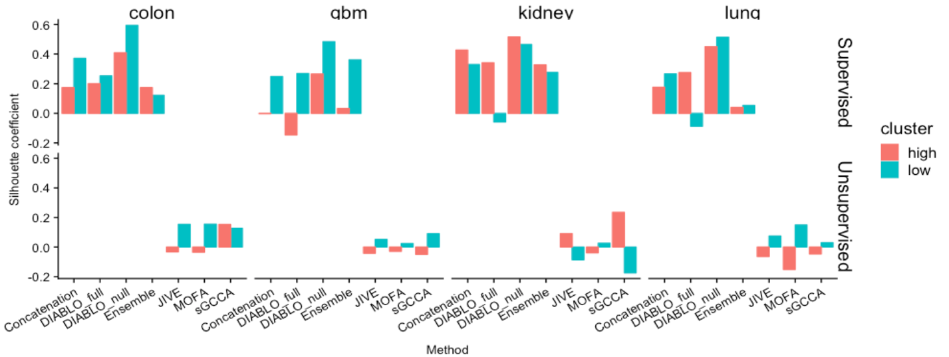

1. Classification performance comparison: Breast Cancer PAM50 subtypes.

|  |  |  |  |  |
| --- | --- | --- | --- | --- |
| Error | SD | Set | Model | Number of variables |
| 0.21 | 0.0091 | train | DIABLO_Null | mRNA: 60, miRNA: 42, CpGs: 22 |
| 0.19 | **NA** | **test** | **DIABLO_Null** |
| 0.22 | 0.0057 | train | DIABLO_Full | mRNA: 55, miRNA: 17, CpGs: 17 |
| 0.21 | **NA** | **test** | **DIABLO_Full** |
| 0.15 | 0.013 | train | Concatenation_sPLSDA | mRNA: 60, miRNA: 0, CpGs: 0 |
| 0.18 | **NA** | **test** | **Concatenation_sPLSDA** |
| 0.14 | 0.0072 | train | Concatenation_Enet | mRNA: 38, miRNA: 2, CpGs: 118 |
| 0.20 | **NA** | **test** | **Concatenation_Enet** |
| 0.25 | 0.014 | train | Ensemble_sPLSDA | mRNA: 60, miRNA: 55, CpGs: 40 |
| 0.28 | **NA** | **test** | **Ensemble_sPLSDA** |
| 0.11 | 0.0016 | train | Ensemble_Enet | mRNA: 96, miRNA: 45, CpGs: 127 |
| 0.23 | **NA** | **test** | **Ensemble_Enet** |

Each integrative method (Concatenation_Enet, Concatenation_sPLSDA, Ensemble_Enet, Ensemble_sPLSDA, DIABLO_Full and DIABLO_Null) underwent hyperparameter tuning (5x5-fold cross-validation) using the training dataset, from which the optimal model (with the lowest error rate) was identified. The optimal model was then applied off-the-shelf to the test data and the balanced error rate was determined. As can be observed from the figure and table, the error rates between the integrative classifiers were comparable; a test balanced error rate ranging from 17-20%. In comparison with other methods, Diablo models selected variables evenly across datasets, whereas the Concatenation scheme was biased towards the more discriminative predictors, mRNA.

3. To find sparse solutions the method requires the users to choose the number active variables per dataset. However, it is unclear how users should make an informed decision on this quantity, as an exhaustive grid search can be very expensive. How sensitive is the method to this choice (which possibly could lead to strong over- or under-fitting)?   
The sparse methods implemented in the mixOmics R-library, including DIABLO use soft-thresholding to replace the $l_{1}$ penalty by the number of variables to select from each component. This improves the usability by the user who can determine a suitable grid for their purposes. A smaller classification model may be favored if the features will be follow-up via candidate experiments or validation studies, where large model are useful for perform gene-set enrichment analyses. Regularization has allowed for improved predictive ability even in cases where all variables are retained, such as in the case of ridge regression as compared to ordinary least squares (Zou and Hastie, 2005). Since all variables are not weighted equally, the irrelvevant variables are down-weighted (lower regression coefficient, loadings) whereas relevant (predictive) variables are up-weighted (larger regression coefficients, loadings).

We provide a tune function within the mixOmics R-library, that performs parameter tuning using a repeated and stratified cross-validation (Rohart *et al.*, 2017). In regards to over and under-fitting, this can be assessed using cross-validation which provides an estimate of the generalizable test erorr.

Minor comments:  
1. In ‘parameter tuning’ it is unclear what is meant by ‘first component’ in l.27 p. 9. Which design matrix is used to calculate this component?

This method was a suggestion for the user to select a particular design matrix by considering the pairwise correlation between components extractsed from PLS models applied to pairs of datasets. For example, in the case of 3 datasets, all pairs of datasets (3 choose 2, 3C2 = 3 pairs) would undergo a PLS model and the correlation between the first component of the X (***t***) and Y (***u***) matrix can be determined. If some components are observed to be highly correlated than these datasets should be connected in the design matrix that will be used for the DIABLO model.

2. The description of visualisation outputs on p. 10 would profit from an illustration in a supplementary figure or including pointers to a corresponding figure in subsequent analyses.

We agree with the reviewer and provide an example and description of each visualization in the supplementary materials.

3. alpha is missing in the objective of equation in p.6, l.7 and has inconsistent sub/superscripts in the equation

not sure what this means?

4. The description on p. 7 uses different notation and naming for loadings/coefficients vectors than on p.6 and differs again from the description in “Prediction distances”. In general, it would be helpful to make this more consistent and avoid duplicated descriptions if possible on these two pages.

Florian to fix?

5. The methods MOFA and JIVE have missing or malformatted citations in the text on p.14

This has been corrected in the revised draft.

6. Typo on p.2 l.31: validation

This has been corrected in the revised draft.

7. Why is the set size different in Fig. 2a between methods? To my understanding the same number of features were used from each method.

For each method 2 components were retained and 30 variables were selected for each dataset, resulting in 30 variables x 2 components x 3 datasets = 180 variables per method. Although the first and second components are orthogonal to each other, some variables were selected on both components. The set size depicts the number of unique features and thus leads to the discrepancy observed by the reviewer. We describe this occurrence in Supplementary Figure S4 of the revised manuscript draft.

8. The message of Fig. 2c (upper panel) is unclear. Do the two large clusters correspond to the two components? What do the grey lines represent? A description thereof should be included into the caption.

Each network depicted the multi-omics biomarker panel (mRNA, miRNA and CpGs) identified using the supervised and unsupervised methods. The gray circles depicted modules based on the edge betweenness index from the igrpah R-library. For the colon cancer dataset it was observed that modules (clusters circled by gray lines) consisted of features that were selected on the two different components. However, this was not true for all the other cancers. This description has been included in the caption of Figure 2 in the revised manuscript.

9. In the supplement the grid parameters for simulation are inconsistent within the text and with the Figure 1a.

This has been corrected in the revised draft of the manuscript.

10. The correlations in Fig. S2 for the uncorrelated simulation setting seem to me still rather high. Could the authors comment on this?

Th figure was depicting an extreme case, in which the level of discrimination (fold-change) and correlation was very high. Since the fold-change is simulated as the difference between the centroids of the two groups, a high level of discrimination between groups resulted in a high degree of correlation between components of different dataset. However, by coloring the two groups these pair-wise correlation scatter plot matrices, we believe this to wrongly indicate that the classification is performed using components of different datasets. Since the classification occurs separately for each omic-type and the predictions are combined using a voting scheme (average, majority, or weighted majority) we have removed this figure for the revised manuscript draft to avoid confusion.

11. Fig. 3a (names of proteins) and Fig. 4f are illegible

We have revised all figures to improve readability and have remove such difficult to read panels to the Supplementary Materials.

References

Aben,N. *et al.* (2016) TANDEM: a two-stage approach to maximize interpretability of drug response models based on multiple molecular data types. *Bioinformatics*, **32**, i413–i420.

Argelaguet,R. *et al.* (2018) Multi‐Omics Factor Analysis—a framework for unsupervised integration of multi‐omics data sets. *Mol. Syst. Biol.*, **14**, e8124.

Bersanelli,M. *et al.* (2016) Methods for the integration of multi-omics data: mathematical aspects. *BMC Bioinformatics*, **17**.

Cun,Y. and Fröhlich,H. (2013) Network and data integration for biomarker signature discovery via network smoothed t-statistics. *PLoS ONE*, **8**, e73074.

Curtis,C. *et al.* (2012) The genomic and transcriptomic architecture of 2,000 breast tumours reveals novel subgroups. *Nature*.

Glass,K. *et al.* (2013) Passing messages between biological networks to refine predicted interactions. *PLoS ONE*, **8**, e64832.

Günther,O. *et al.* (2012) A computational pipeline for the development of multi-marker bio-signature panels and ensemble classifiers. **13**, 326.

Huang,S. *et al.* (2017) More is better: recent progress in multi-omics data integration methods. *Front. Genet.*, **8**.

Kim,D. *et al.* (2013) ATHENA: Identifying interactions between different levels of genomic data associated with cancer clinical outcomes using grammatical evolution neural network. *BioData Min.*, **6**, 23.

Kirk,P. *et al.* (2012) Bayesian correlated clustering to integrate multiple datasets. *Bioinformatics*, **28**, 3290–3297.

Langfelder,P. and Horvath,S. (2008) WGCNA: an R package for weighted correlation network analysis. *BMC Bioinformatics*, **9**, 559.

Li,W. *et al.* (2012) Identifying multi-layer gene regulatory modules from multi-dimensional genomic data. *Bioinformatics*, **28**, 2458–2466.

Liquet,B. *et al.* (2012) A novel approach for biomarker selection and the integration of repeated measures experiments from two assays. *BMC Bioinformatics*, **13**, 325.

Lock,E.F. *et al.* (2013) Joint and individual variation explained (JIVE) for integrated analysis of multiple data types. *Ann. Appl. Stat.*, **7**, 523–542.

Ma,S. *et al.* (2016) Breast cancer prognostics using multi-omics data. *AMIA Summits Transl. Sci. Proc.*, **2016**, 52.

Meng,C. *et al.* (2016) Dimension reduction techniques for the integrative analysis of multi-omics data. *Brief. Bioinform.*, **17**, 628–641.

Ritchie,M.D. *et al.* (2015) Methods of integrating data to uncover genotype–phenotype interactions. *Nat. Rev. Genet.*, **16**, 85–97.

Rohart,F. *et al.* (2017) mixOmics: An R package for ‘omics feature selection and multiple data integration. *PLOS Comput. Biol.*, **13**, e1005752.

Sokolov,A. *et al.* (2016) Pathway-based genomics prediction using generalized elastic net. *PLoS Comput Biol*, **12**, e1004790.

Tenenhaus,A. *et al.* (2014) Variable selection for generalized canonical correlation analysis. *Biostatistics*, **15**, 569–583.

Tenenhaus,A. and Tenenhaus,M. (2011) Regularized generalized canonical correlation analysis. *Psychometrika*, **76**, 257–284.

Wang,B. *et al.* (2014) Similarity network fusion for aggregating data types on a genomic scale. *Nat. Methods*, **11**, 333–337.

Westerhuis,J.A. *et al.* (2010) Multivariate paired data analysis: multilevel PLSDA versus OPLSDA. *Metabolomics*, **6**, 119–128.

van de Wiel,M.A. *et al.* (2016) Better prediction by use of co-data: adaptive group-regularized ridge regression. *Stat. Med.*, **35**, 368–381.

Yugi,K. *et al.* (2016) Trans-omics: how to reconstruct biochemical networks across multiple ‘omic’ layers. *Trends Biotechnol.*, **34**, 276–290.

Zeng,I.S.L. and Lumley,T. (2018) Review of Statistical Learning Methods in Integrated Omics Studies (An Integrated Information Science). *Bioinforma. Biol. Insights*, **12**, 117793221875929.

Zhang,S. *et al.* (2011) A novel computational framework for simultaneous integration of multiple types of genomic data to identify microRNA-gene regulatory modules. *Bioinformatics*, **27**, i401–i409.

Zhang,S. *et al.* (2012) Discovery of multi-dimensional modules by integrative analysis of cancer genomic data. *Nucleic Acids Res.*, **40**, 9379–9391.

Zhu,J. *et al.* (2012) Stitching together multiple data dimensions reveals interacting metabolomic and transcriptomic networks that modulate cell regulation. *PLoS Biol.*, **10**, e1001301.

Zou,H. and Hastie,T. (2005) Regularization and variable selection via the elastic net. *J. R. Stat. Soc. Ser. B Stat. Methodol.*, **67**, 301–320.